Window to Bolivia

Providing A Glimpse Into Another Part Of Our World
Bolivian Youth Ministries Jonathan and Linda Baker
** August 2006 **

The
Love the Lord your God with all your heart, soul, mind and strength. Love those around you as you love yourself. Everything is fulfilled in these two commandments.

PRAYER
* Please pray for good health for each of the girls and our family. It’s been a tough Winter (May-July) with many colds and sore throats.
* Pray that our family would find some rest in Oregon (see Praise) this Aug-Sept. The ministry here can be very wearying.
* Please pray for the continued financial stability of this ministry. God is ever faithful and we trust Him completely.
* Ask that the Love of Christ will shine in the lives of each and every child in our care.

PRAISE

* Thanks to the Lord (and an overbooked AA flight) we will be able to spend some needed down-time in Oregon this Aug-Sept at a fraction of the normal cost.
* We have finally moved into our new, cozy (small) home. Now the third home is freed up to be used as God desires. We hope to open it for new girls around the first of the year.
* We thank the Lord that He continues to fight the battle for us. The warfare that takes place around us is very real, sometime seen, sometimes not. We couldn’t do it on our own.

Retro>Introduction>WhatItsAbout<dScoop<Vintage

It’s been about eleven years since we packed up the Model T with all our belongings and headed West to find our fame and fortune. Alright, that’s not exactly the way the story goes but we did pack up our five children and headed South to seek God’s will. Little and Much has changed in those eleven years.

After eleven years our family lives on two continents; make that three in a year or so. We miss them dearly. We also miss seeing our first grandchild. We know, you’re thinking, “Dude! You can’t be a Grandpa”. It’s true.

What hasn’t changed is the focus of the ministry here in Bolivia. God is reaching out to a group of girls that, we truly believe, wouldn’t be reached otherwise. Frankly put, a group of girls that have been abandoned, beaten and abused. Girls that have witnessed the murder of a parent, have been used in drug trafficking, have lived in a men’s jail, have been forced to beg on the streets for someone else and have lived in the streets with glue-sniffing relatives

Through the grace of God these girls find themselves here… Whoa, look, we’re not praising ourselves, no way! We’re praising the God of the heavens for providing an oasis away from the stench of sin. It is God and God alone that’s doing this. HE is the one who has brought some incredible workers (house mums) to us. HE is the one that is raising support. HE is the one who strengthens us when we’re weak. It’s only by His grace we are sustained.

Now where was I: Through the grace of God these girls find themselves here… In this Spiritual Oasis they find most importantly the Love of Christ. They witness that adults, parents and siblings can actually be loving and caring, that they don’t have to fear, that they really can trust others and in turn trust God. Here they receive Spiritual, Physical, Social and Psychological nourishment.

We are going to continue on as long as God is providing and willing. We hope to see some of these girls graduate from college and go on to be doctors, teachers and missionaries. We hope to see them praising God with their mouths and through their actions. Most importantly we hope to see them in heaven one day at the throne. >>>Enjoy the pics; God and People are what it’s about.<<<
The Two Commandments and you.

Y’know, there’s a pretty strong argument to be made that the only things in the universe that are eternal are 1) God and 2) people. That simple fact tends to put life into perspective.

When we live our lives for the right reason, the reason found in Luke 10, we live a life of true joy and fulfillment. We live our lives for which they were created. Any other reason is fleeting and will never bring the fulfillment that we crave. Knowing these facts is the first step in living a God-centered life of value.

<So, how do you get there?>

- Confess and repent
- Commit your heart to Jesus Christ
- Live holy
- Fellowship with other Christians
- Center every moment, every thought on God
- Read His Word
- Reach out and meet the needs of others

Sound simple? It is. Sound easy? It isn’t. Living a life of value is incredibly difficult. Fortunately we have a Father to help us out.

Live your one and only
eternal life for the Lord.
“The greatest fulfillment in life is to give it up for something that outlasts it.”

Jonathan & Linda Baker
Rosa and Joanna
(Bolivia)
Ryan, Joshua and Zachary
(US)
Kyle, Diana and Todd
(US)

26987 Fern Ridge Road
Sweet Home, OR 97386

Misión Niñez Boliviana
Cajón 3471
Cochabamba
Bolivia

www.BYMinistries.org

BYM@BYMinistries.org

Please look at our website for lots of good pix and information.
Email us any time!
¡MUSIC!

Oh, the suffering souls
Crying out for love
In a world that seldom cares
See the hungry hearts
Longing to be filled
With much more than our prayers

And a young girl sells herself on
Seventh Avenue
And you hear her crying out for help
My God! What will we do?

Don’t tell them Jesus loves them
Til you’re ready to love them too
Til your heart breaks from their sorrow
And the pain they’re going through
With a life full of compassion
May we do what we must do
Don’t tell them Jesus loves them
Till you’re ready to love them too

All the desperate men
Are we reaching for the souls
That are sinking down in sin?
Oh, cry for the Church
We’ve lost our passion for the lost
And there are billions left to win

And another 40,000 children starved to
death today
Would we risk all we have
To see one of them saved?

Why have we waited so long
To show them Jesus lives
To share salvations’ song
Why have our hearts become so proud
That we fail to see
To love them is to love God.

Steve Camp
Bolivian Youth Ministries
Sweet Home Community Chapel

42250 Ames Creek Road
Sweet Home, OR 97386
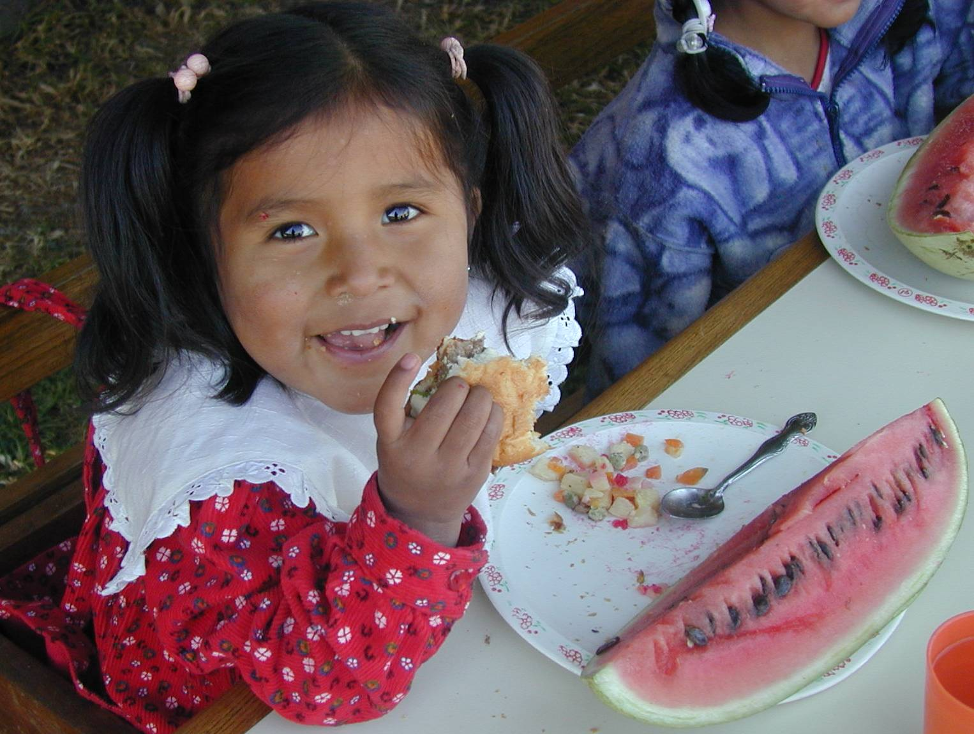
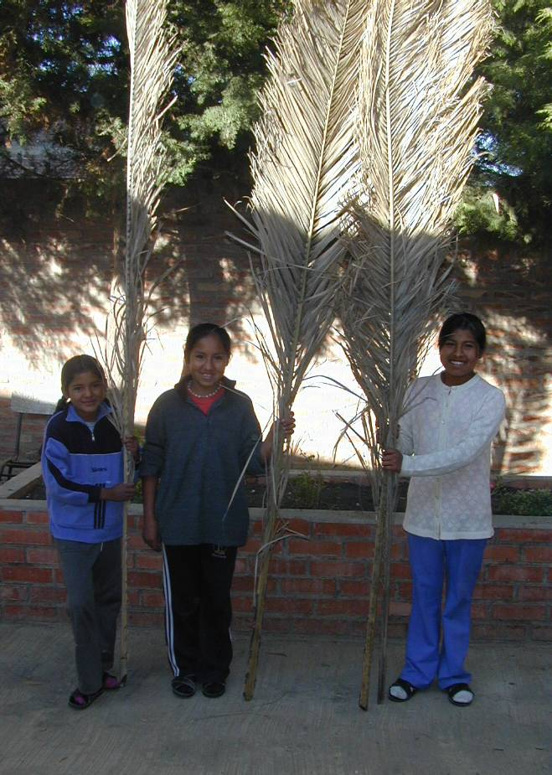
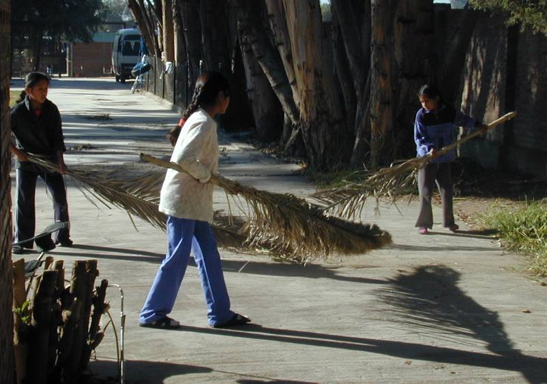
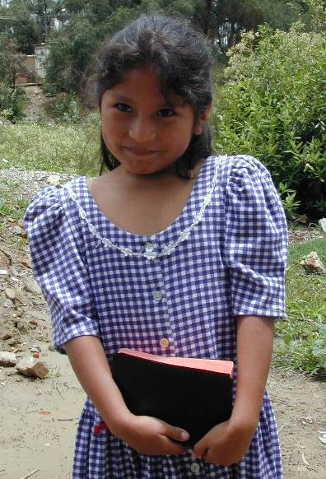
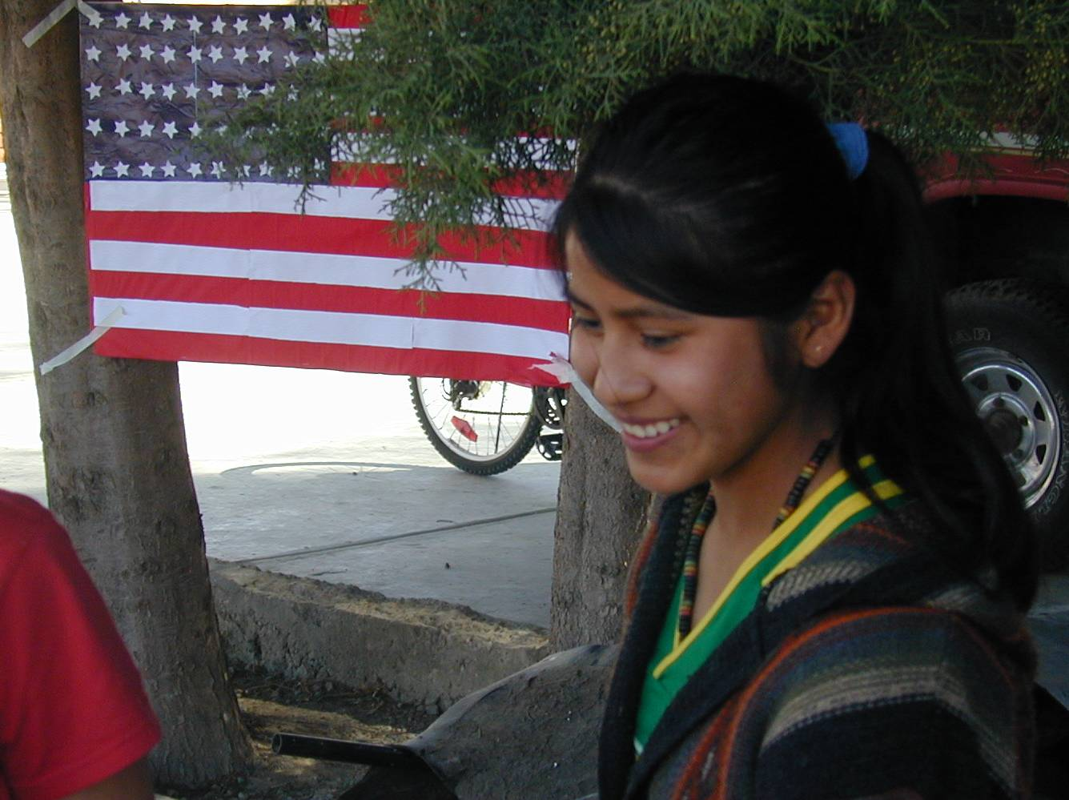
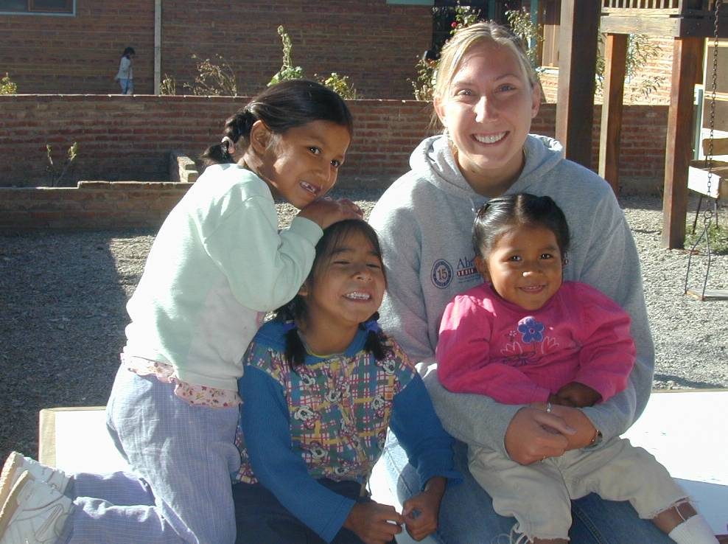
Yeraldin, Betty and Elizabet:
The Saturday morning sweeping crew!
Heather with Laura, Leydi and Juanita
Gilda is the indisputable champ for cutest Going-To-Sunday-School Girl.
A Christ-filled Helen in front of the flag the girls made for the Fourth of July. Thanks J & T S.
Jocelyn and a new bike.
Juanita in paradise.
